**PRACTICAL 2: Storage as a service using AWS**

Name: Anshika Sharma

SAP ID: 86062300034

Roll No: A061

1. Navigate to the AWS website and search for S3

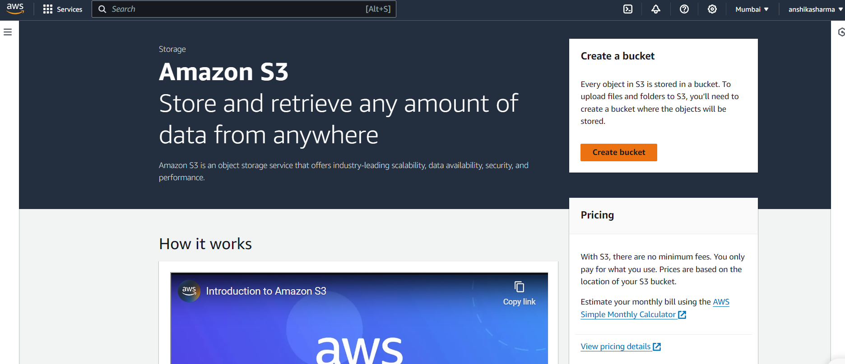

1. Click on "Create bucket" and name it as “ccpract22”

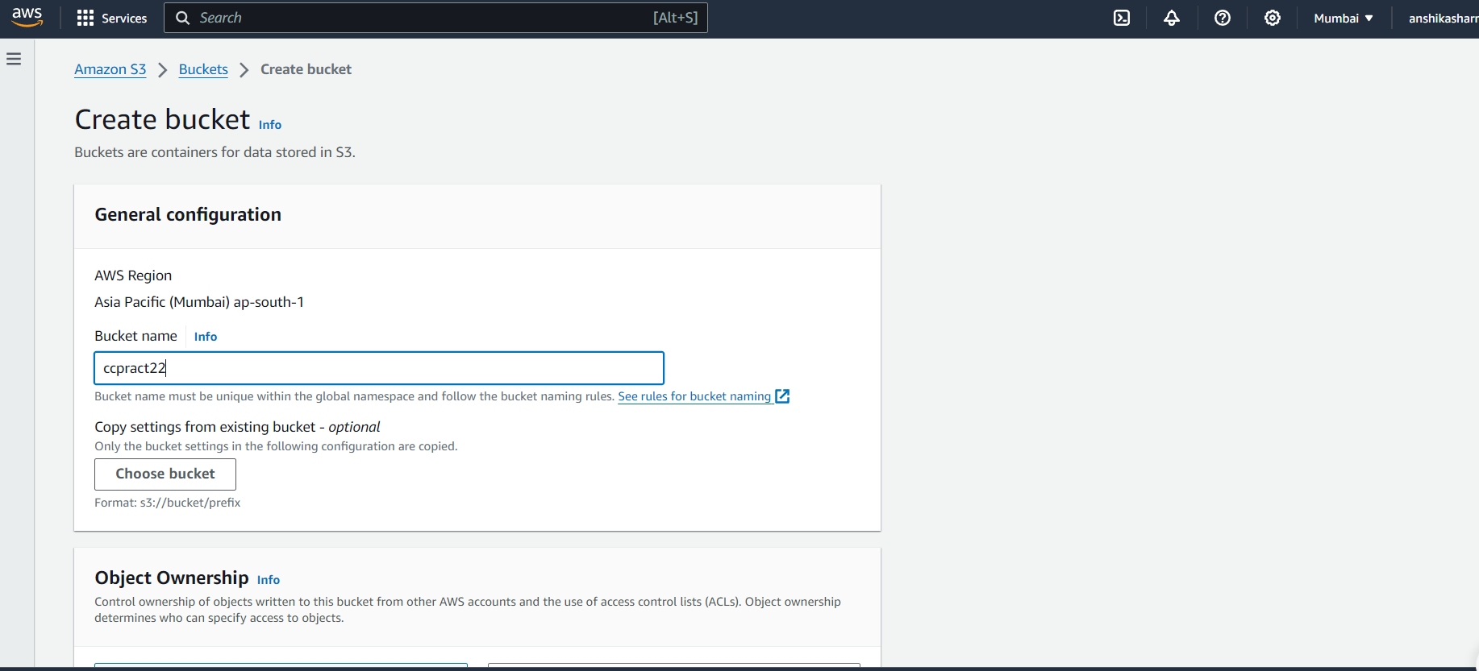

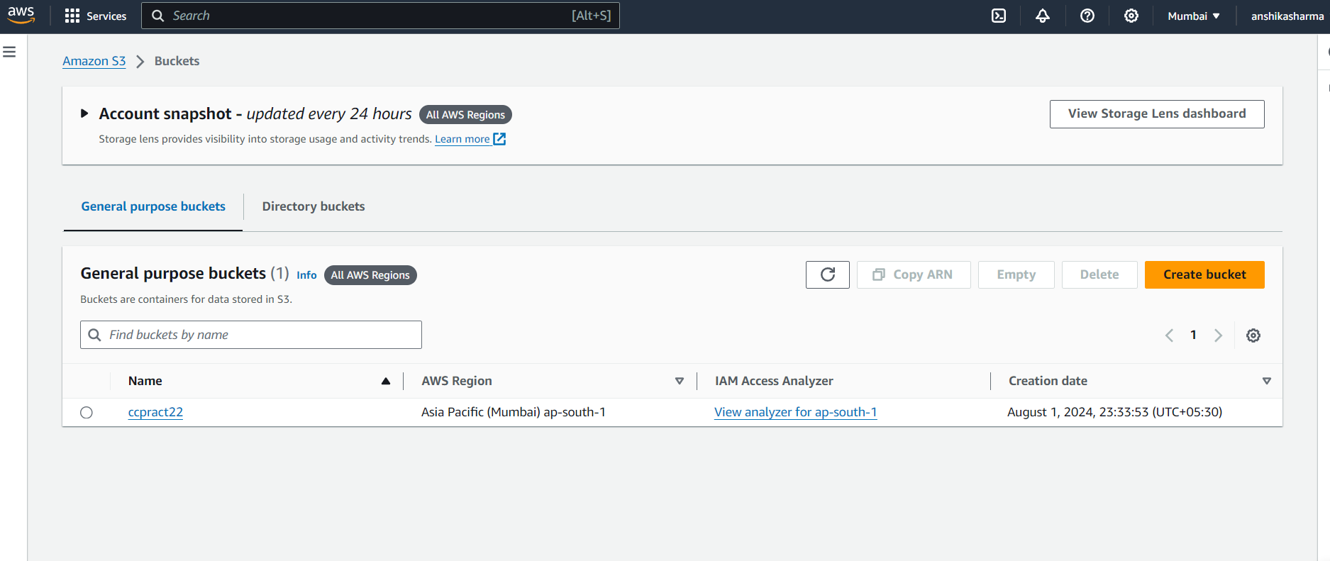

1. Create a new folder within the bucket and name it "day2".

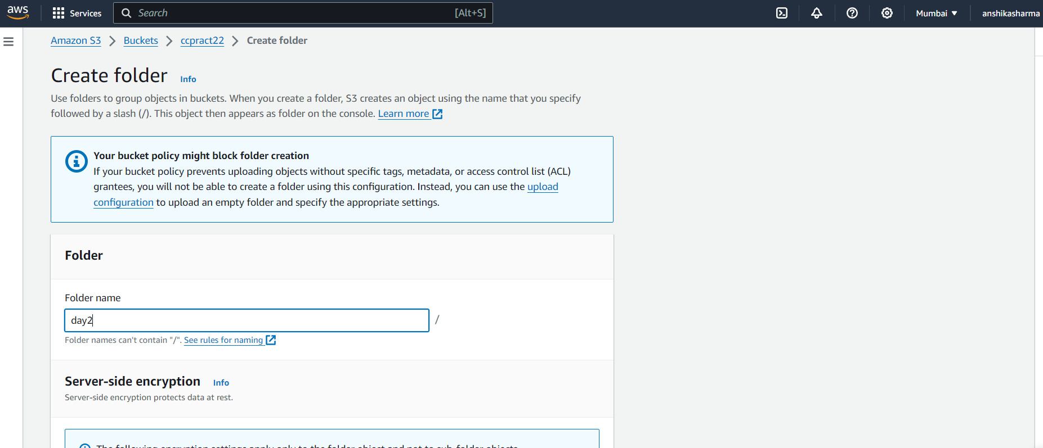

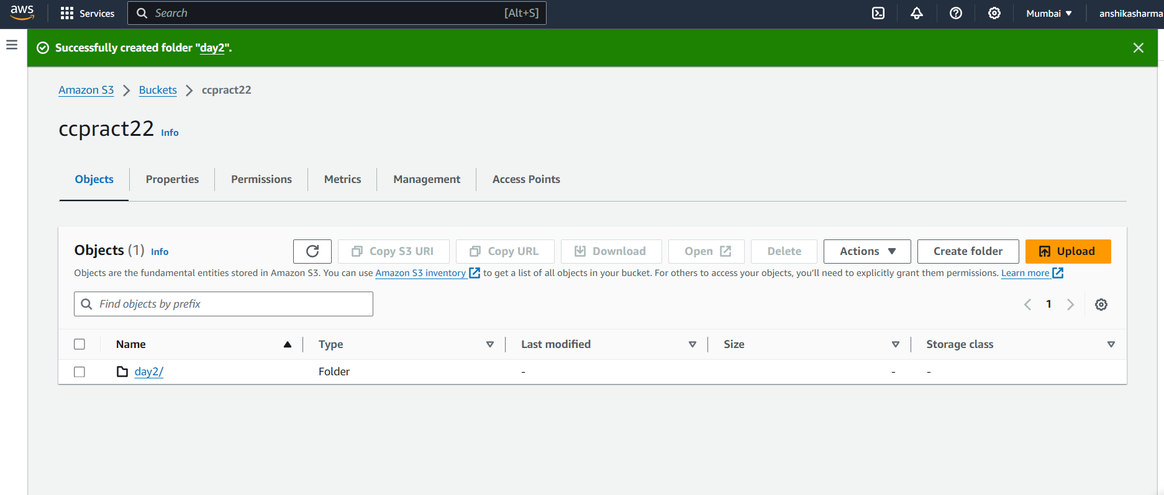

**Uploading Photo**

1. Download an image from Google and save it as .png, .jpg, or any other format.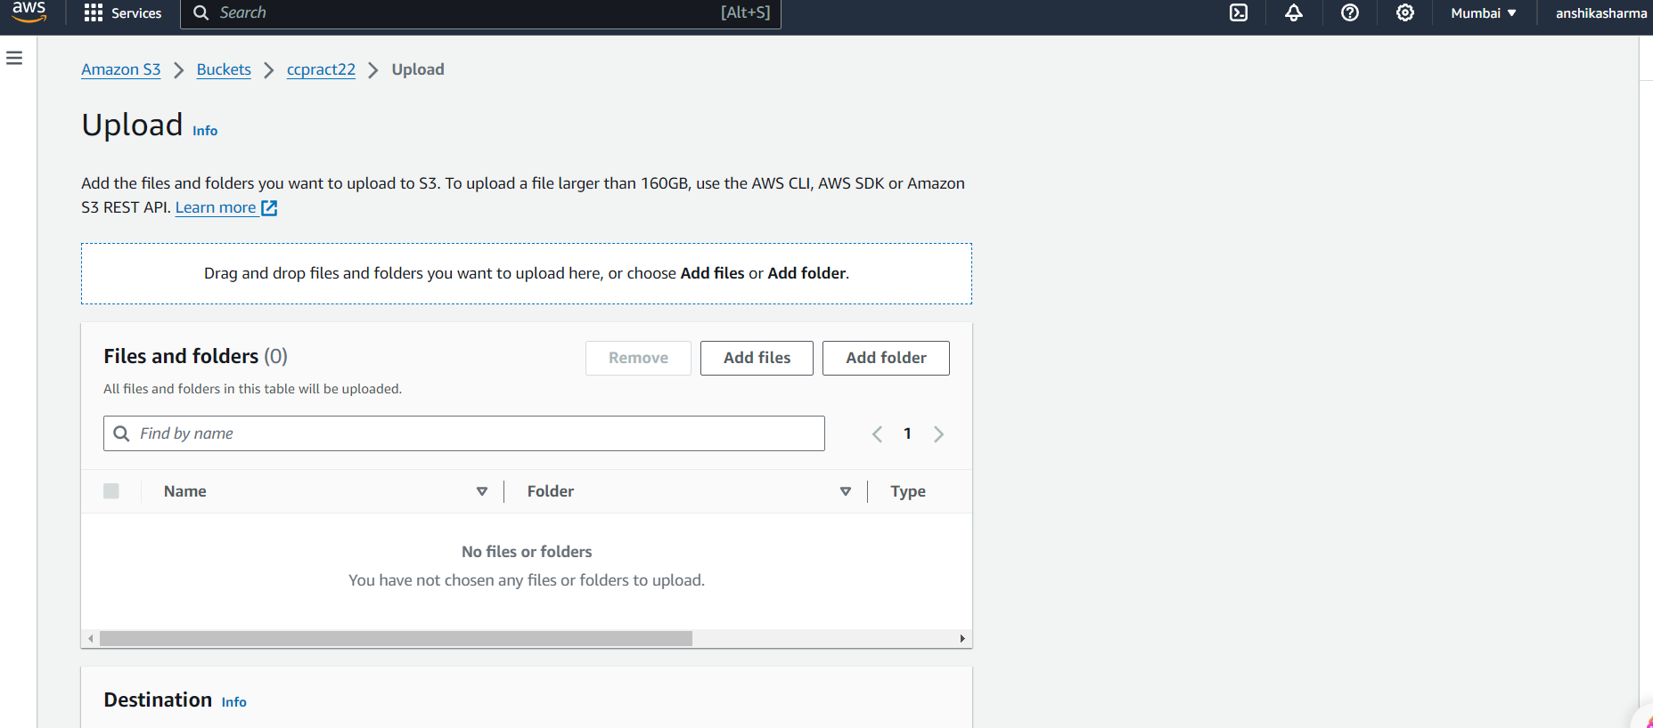
2. Go to the "ccpract22" bucket and upload the downloaded image

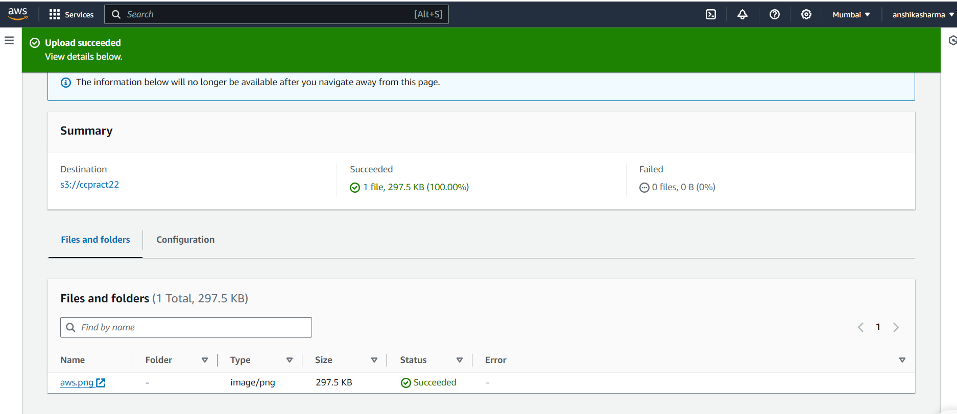

1. After the upload is successful, open the image file.

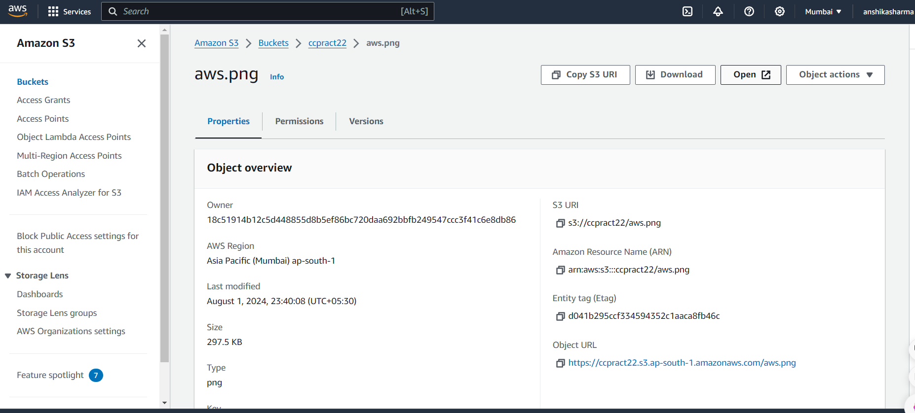

1. The image is now uploaded.



**HTML Page**

1. Save a simple HTML file in Notepad as “content.html”.

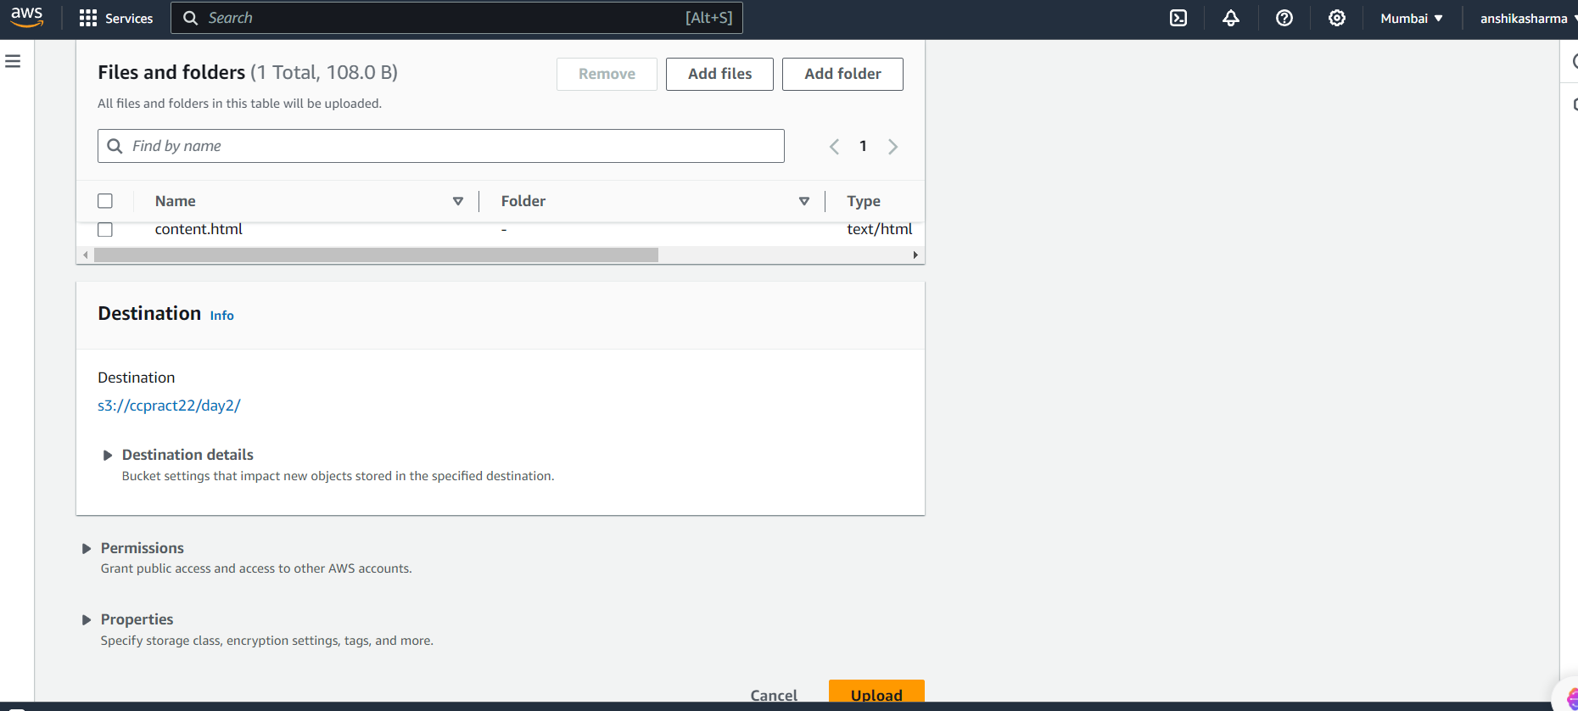

1. Upload the “content.html” file to the "day2" folder

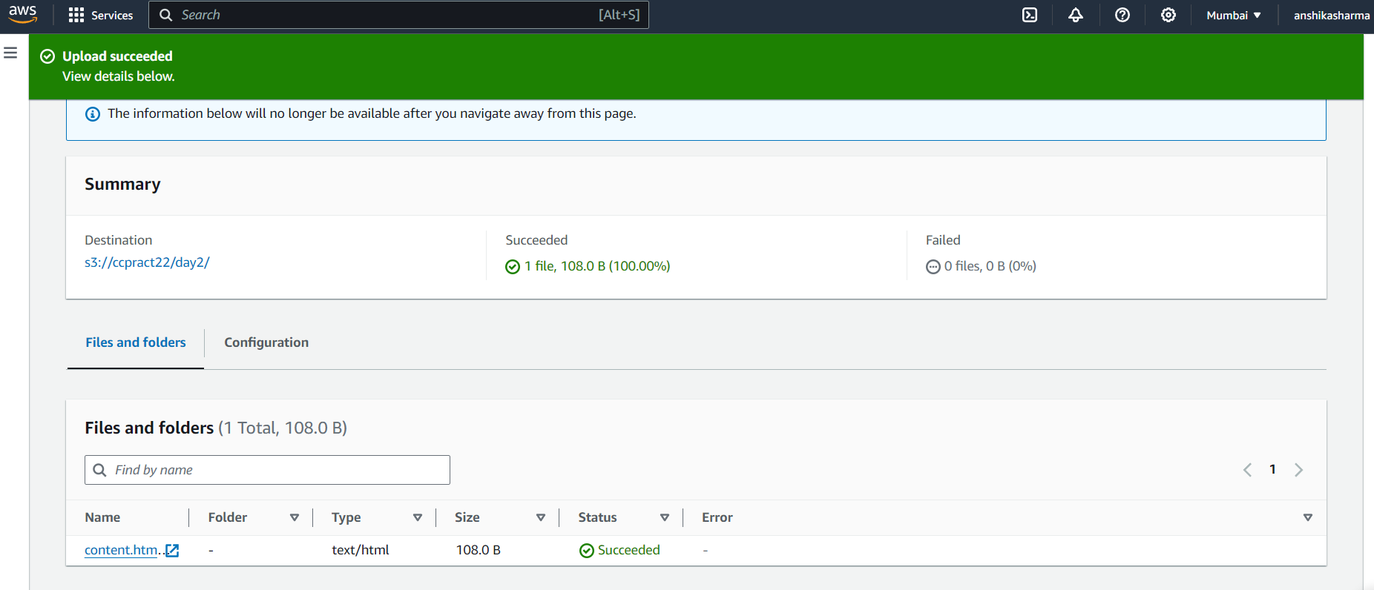

1. Once the upload is successful, open the uploaded file.

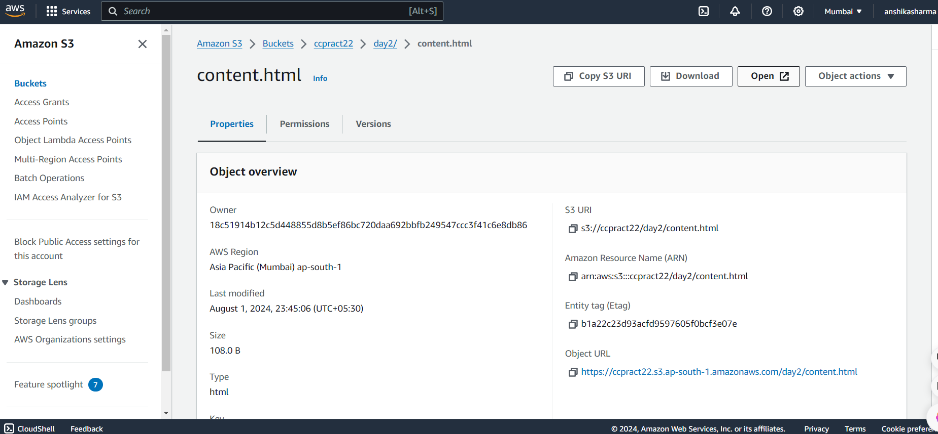

1. . The basic HTML page is now uploaded which opens as below.

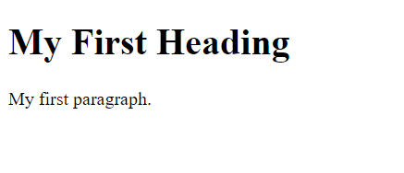

**For website Frontend**

12. Write the front-end HTML code for a website and save it as “website.html” in Notepad.

13. Upload the “mywebsite.html” file to the "ccpract22" bucket.

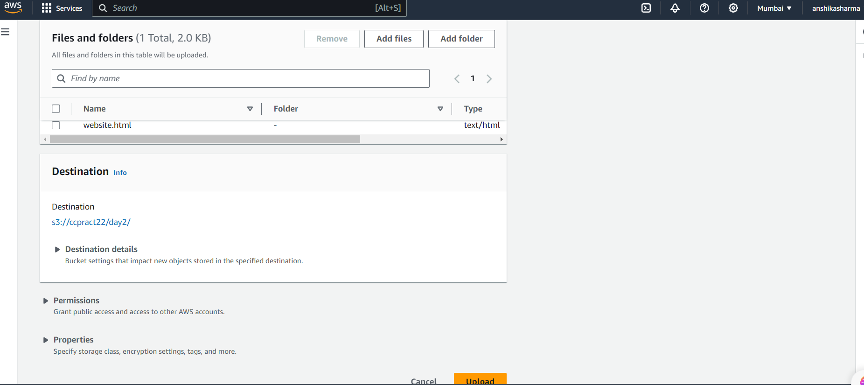

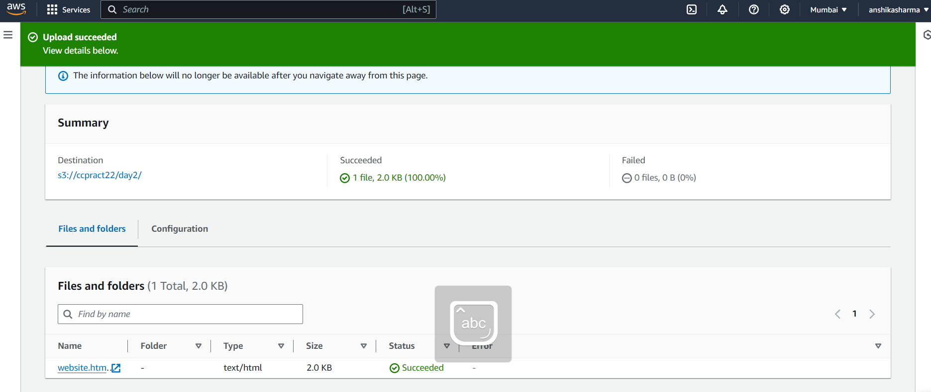

14. After a successful upload, open the file to launch your website.

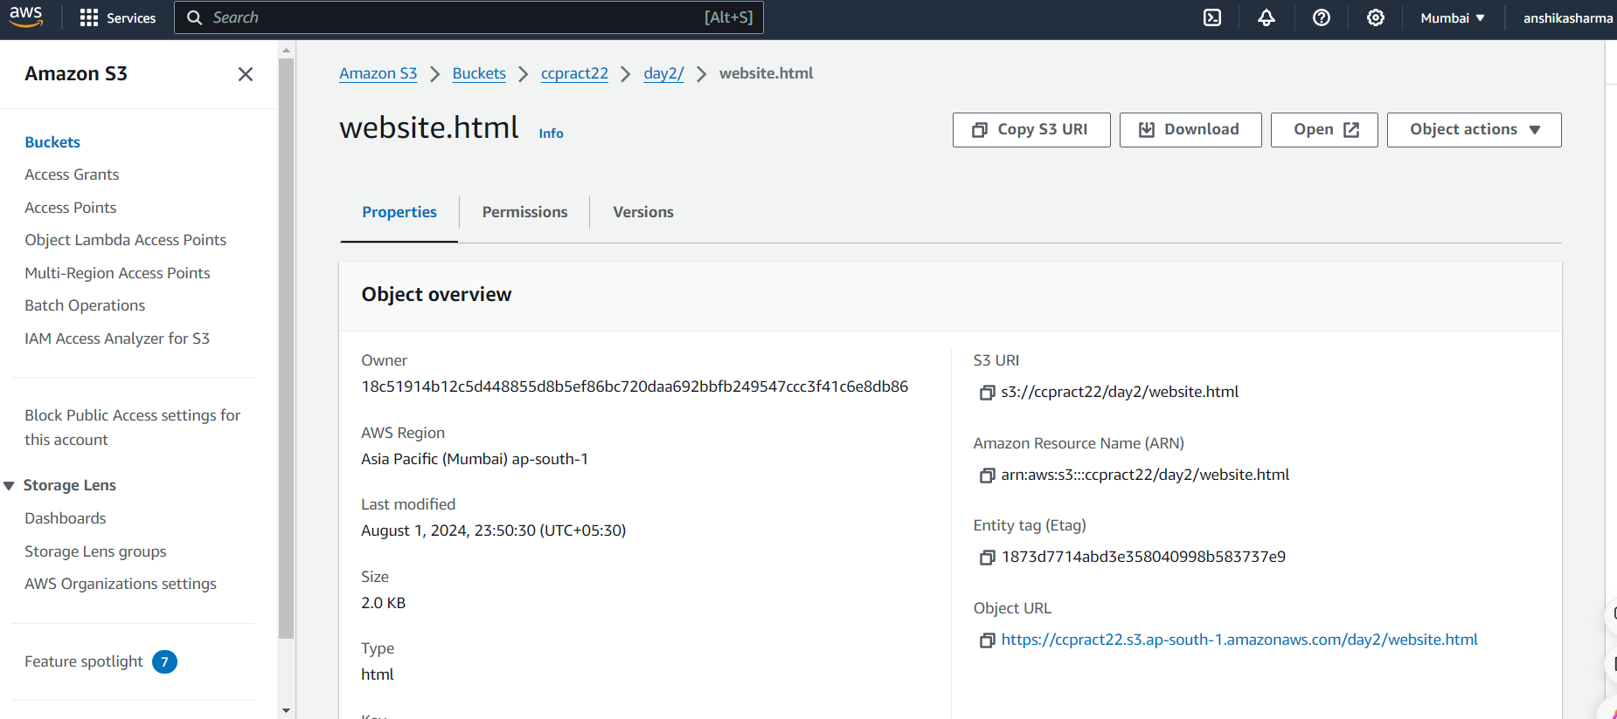

15. The website setup is now complete.

